Java Practical with IntelliJ

**Objectives**

The objectives of this practical session are to:

* Define a new class
* Provide a class with constructors, methods and variables
* Create objects of that class
* Test the instance methods of a class

**Overview**

This practical consists of two parts plus an optional part. In Part 1, you will define a simple class called Employee that will model an employee of a company. You will provide that class with just two instance variables for the employee’s name and age, respectively. You will also provide a constructor to initialise these variables with some values. To test this class, you will also need to define another class called EmployeeTest. Here, you will create two objects of the Employee class and display the details of each employee. Since, the Employee class does not (as yet) have any instance methods, you will have to access its instance variables directly.

As you have learnt, it is bad practice to allow a user of your class to access your instance variables directly. So, in Part 2 of this practical, you will provide the Employee class with two instance methods to return the values of the employee’s name and age, respectively. Then, you will modify the EmployeeTest class to make use of these new instance methods rather than accessing the instance variables directly. You will also add another instance method to the Employee class to allow a user of the class to increment the employee’s age. The company isn’t really interested in an employee once he or she reaches retirement age, but, to be kind, you are going to freeze their age once they reach retirement age. In other words, your method will not increment the employee’s age beyond, say, 65.

**Practical**

|  |  |
| --- | --- |
| Part 1. Defining a Class and Creating Objects of that Class |  |

1. Locate the your copy of IntelliJ, and launch it.
2. On the next screen, create a project using the menu **Create New Project**.

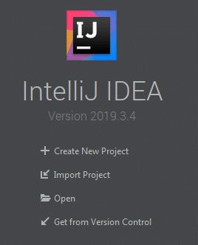

1. Select a Java Project, and hopefully you can use a Java 8 installation, or configure one.

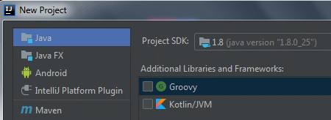

1. Click **Next** twice. Give the project the name ‘Employees’, choose a suitable directory path, and **Finish**.

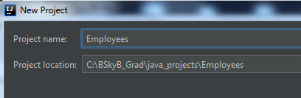

This will nodoubt prompt you to create the folder.

1. The project is created. If you open up the structure, you will see that many libraries (JAR files – Java Archives) have been included by default. There is also a src folder, which is where the source code (.java files) will go.
2. Highlight ‘src’, right-click and create a new class via **New > Package**. Give it a name qa.emp, and the within this, create a new **Java Class**, with name EmployeeTest.

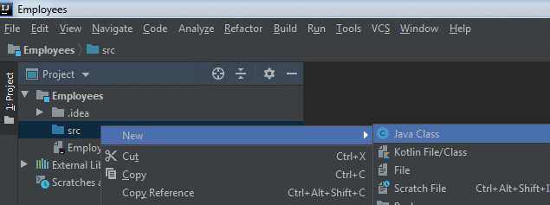

Click **Finish**.

1. For this class you will define a main() method. There is a shortcut in IntelliJ which helps: psvm. Another shortcut sout allows you to define a print statement (System.out.println()). Use this to print out the message “Employee details:” with a statement.

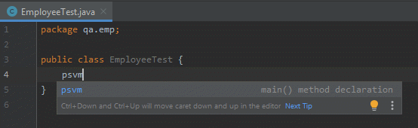

1. Save your work, using the save button, **File** menu, or **CTRL S**. Then use the **Build > Make Project** option to compile your code. If there are any errors, a message appears – fix the error, save and **Build > Rebuild Project** again!
2. Highlight EmployeeTest, and execute your program via the menu **Run > Run ...**.

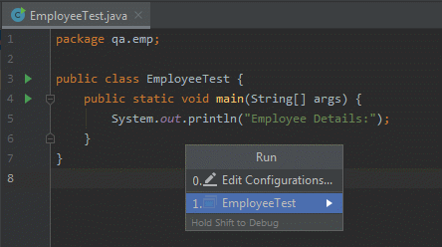

Note you need to select the main class, EmployeeTest. You can also run by right-clicking the EmployeeTest class on the left, and **Run 'EmployeeTest.main()'**.

1. This should run successfully, and your output appears in a window at the bottom.
2. Now, in similar fashion to step 6 above, create a new class, belonging to the same package, called Employee. This will be used in later practicals